Name: ______________________________
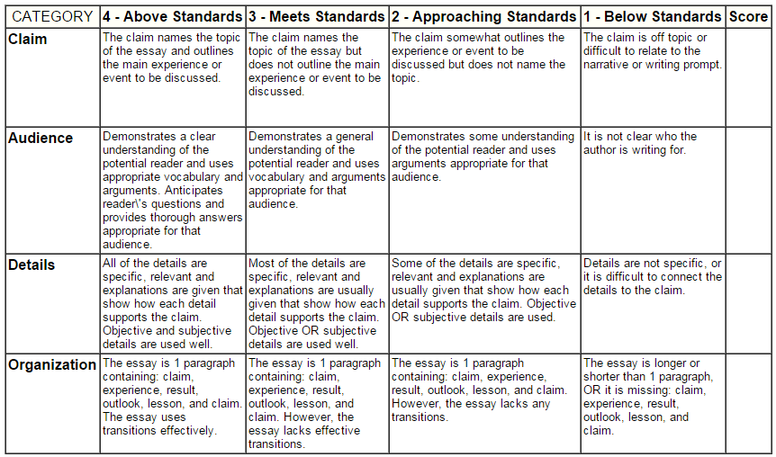

Name: ______________________________

